

MS SQL SERVER 2019 tOC



November 17, 2022

CU Raise analytics pvt ltd (Treelance)

Bangalore

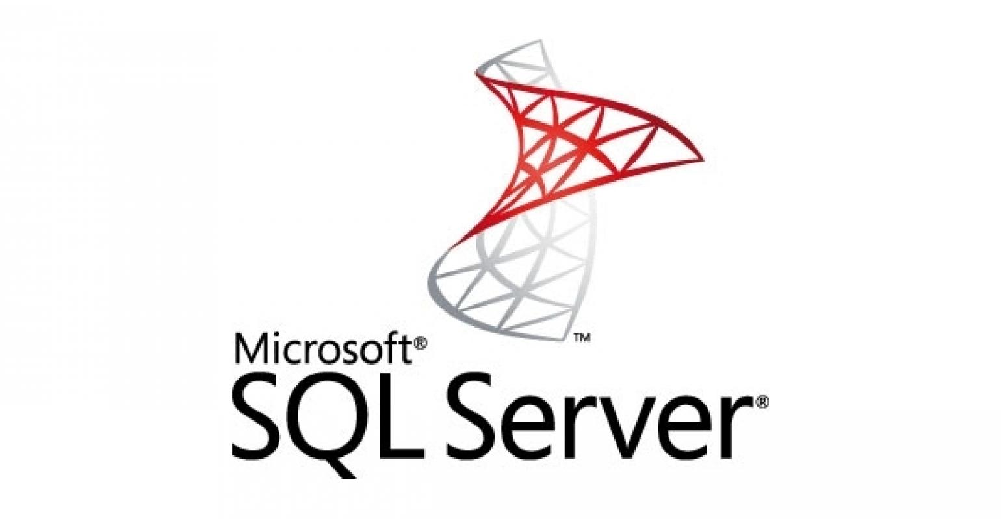

# **SQL**

Module 1: **Introduction to Basic Database concepts**

* + - * What is Database and use of DB?
      * Different Types of Databases
      * How Are Databases Used in the Real World?
      * What is DBMS and RDBMS
      * Data models in DBMS

Module 2: **E-R Modeling and Diagrams**

* Components of E-R Diagram
* Different Types of Mapping constraints

Module 3: **Normalization and Denormalization**

* What is Normalization
* Types of Normalization forms (1NF,2NF and 3NF)
* What is De-normalization
* Difference B/W Normalization and Denormalization
* Examples for Normalization and Denormalization

Module 4: **Introduction to SQL Server**

* What is SQL Server Version history and different editions?
* Basic Features Components and Tools
* Starting and Stopping SQL Server Instances / Services
* Introduction to Management Studio
* Types of System Databases in SQL

Module 5: **Introduction to SQL**

* + - What is SQL and use of SQL
    - Data types in SQL
    - SQL Server Languages (DML, DDL, TCL, DCL)
    - Working with basic commands
    - Operators and Aliases in SQL

Module 6: **Functions in SQL**

* String Functions
* Numeric Functions
* Date Functions
* Null Functions
* Aggregate Functions
* System Functions

<https://www.sqlservertutorial.net/sql-server-system-functions/>

* Window Functions

Module 7: **Clauses in SQL**

* Where Clause
* Group By
* Having
* Order By

Module 8: **Working with constraints --- Last adding**

* + - * Not Null
      * Check and Default
      * Unique and Primary
      * Foreign key
      * Listing, Adding and dropping constraints

Module 9: **Joins**

* + - * Introduction to Joins
      * Types of Joins
* Inner or equi or Simple
* Cross join
* Outer join (Left, Right and Full outer)
* Self-Join

Module 10: **Set Operators**

* Introduction to Set Operators
* Types of Set Operators

Union

Union All

Intersect

Except

Module 11: **Schema**

* What is Schema and Advantages of using Schema?
* Built in Schemas in SQL Server
* How to create, Alter and drop schema

Module 12: **Views**

* Introduction to View and advantages of View
* Types of Views (Simple and Complex)
* Creating, Renaming, Listing and removing a View
* Creating an indexed view and getting view information

Module 13: **Subqueries – Last part Adding**

* What is Subquery and Nested Subquery
* Operators in Subquery
* Derived Table
* Corelated Subquery

Module 14: **Working with Indexes and Synonyms**

* + - What is Index and advantages of Indexes?
    - Clustered and Nonclustered indexes
    - Unique Indexes
    - Create, rename, disable, enable and drop indexes
    - What is Synonym and when to use Synonym?
    - Create, Drop and Listing Synonym
    - Advantages of Synonym

Module 15: **Sequences**

* What is a Sequence
* Create Sequence statement
* Alter Sequence, Listing Sequence and drop sequence
* Sequence vs Identity columns

Module 16: **CTE (Common Table Expression)**

* Introduction to CTE
* Examples for CTE

Module 17: **Temp Table, Table variable**

* + - * Different ways Creation of Temporary Tables
      * Global Temporary Table
      * Advantages of Temp Table
      * Dropping Temp Tables
      * Declare Table Variable

Module 18: **Miscellaneous**

* Create database
* Load sample database
* Import and export tables
* drop database
* Select Top
* Offset and Fetch
* Rollup
* Cube
* Case
* Identity column
* Select Into
* Insert into Select
* Bulk insert in SQL Server
* SQL Server 2019 New Features
* Pivot
* XML Data types in SQL Server

Module 19: **Dynamic SQL**

* Introduction to Dynamic SQL
* Build and Execute Dynamic SQL
* Dynamic SQL for DML, DDL and Stored Procedure

**T-SQL**

Module 1: **Introduction**

Module 2: **Variable declaration**

* Local variables (user defined variables)
* Global variables (System defined variables

Module 3: **Decision Making Statements**

* IF
* IF ELSE
* Nested IF

Module 4: **Loops**

* Introduction to Loops
* While Loop
* While Loop with Break
* While Loop with Continue

Module 5:  **Cursors**

* Introduction to Cursors
* Types of Cursors
* Life cycle of Cursor
* Cursor declaration
* Examples of Cursors

Module 6: **Exceptions**

* + - * What is Exception and How to handle the exception?
      * Syntax of Exception handling
      * Types of Exceptions

1. System Defined
2. User Defined

* Examples for Exceptions

Module 7: **Stored Procedure**

* What is Procedure and use of Procedure?
* Basic syntax for Procedure
* Types of Procedures

1.User-defined Procedures

2.System Procedures

* Procedure creation, Execution, Modify, Rename and dropping
* Parameterized Procedure creation
* Examples

Module 8: **User Defined Functions**

* What is Function and use of function?
* Types of UDF

1. Scalar functions
2. Table-valued functions

a. Inline table-valued functions

b. multi-statement table-valued functions

* Differences B/W Procedure and Functions

Module 9: **Triggers**

* What is Trigger and use of Triggers?
* Different Types of Triggers

1.DML Triggers

2.DDL Triggers

3. Logon Triggers

* Modify/Enable / Disable / Drop the Triggers
* Advantages / Disadvantages of Triggers

**Performance Tuning Concepts**

Query Optimization

Execution Plan / Explain Plan

Tuning Tips for Improving Query Performance

**Job Scheduling in SSMS**